*Chapter 4, Problem 42.

For the circuit in Fig. 4.109, find the Thevenin equivalent between terminals a and b.

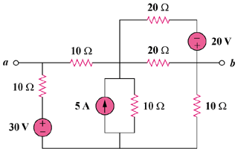

Figure 4.109
For Prob. 4.42.

